**5 Strategy 3: Desalinization**

Desalinization refers to the process that removes some amount of salt and other minerals from saline water, thus providing fresh water for human use and irrigation. Saline water is no doubt a huge source of water supply, so some coastal regions have adopted desalination to solve water shortage, such as Saudi Arabia [16] .

In China, Tianjin operates a desalinization plant to alleviate local critical water shortage. But desalination has not been extensively used across China. Here, we apply a NPV (net present value) method to examine the costs and benefits of establishing desalination plant and further decide whether to implement desalination.

**5.1 Potential Locations for Desalination**

Due to the nature of desalinization, target locations are restricted to costal regions. We first choose potential locations along cost according to the extent provinces are in water shortage. Based on our prediction in Section 2, we narrow down our target to 5 provinces that will be in severe water shortage in 2025, including Bejing, Tianjin, Shanghai, Jiangsu province and Shandong province(see Figure 13). Priority should be given to Jiangsu province with a predicted gap of 58.324 billion .

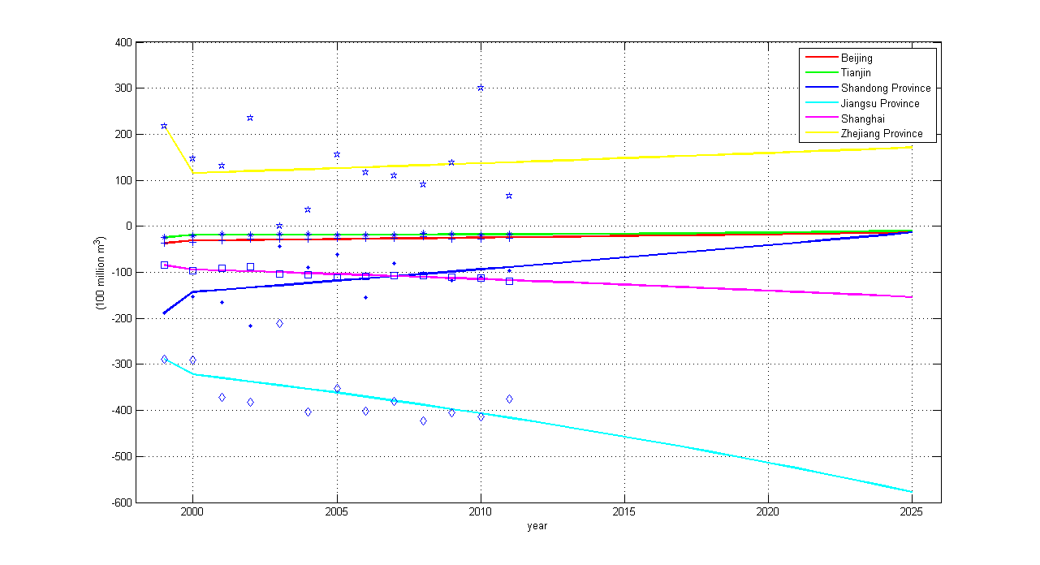

Figure 13: Comparison of water gaps in 6 provinces

Assume that it is feasible to establish desalination plants, both technologically and geologically, we next focus on its economic and social implications to see whether the potential social benefits exceed economic cost.

**5.2 Assumptions**

* **Desalination plant aims to fully satisfy the predicted water gap in each province.**
* **No difference exists among desalination plants.** Each plant has the same capacity, initial investment, unit cost and operating cost.
* **It takes 2 years to construct a plant, which is the average time needed.**
* **We use contribution of water to local GDP as benefits of desalination plant.** Water is critical to agricultural production, industrial output and urban consumption, which further influence local GDP.

**5.3 Notations**

* : Cash flow of the province in period t.
* : Water contribution to GDP in province i.
* : GDP for province i in period t.
* : Water supply for province i in period t.
* : The number of plants that each province need to establish to satisfy the water gap.
* : Initial investment for each plant. We assume it to be 2 billion yuan.
* : Operating cost for each plant. We assume it to be 147 million yuan.
* : Capacity for each plant. We assume it to be 5 billion yuan.
* : Unit cost of dealing saline water for each plant. We assume it to be 1.5 million yuan.
* Discount rate. We set it to be 5.12%.

Note that the estimation are based on *the prospectus for desalinization plant in Taoyuan, Taiwan.* [14]

**5.4 Cost-Benefit Analysis**

As we can see, costs include initial investment, operating cost per year and cost of dealing saline water per year, while benefit is defined as the contribution of water to local GDP. In each period, cash flow of establishing a desalination plant equals to:

Where , and are the average of the past three year's data for each province. Dividing water gap by the capacity, we can get the number of plant needed for each province, which is 1 for Beijing, 1 for Tianjin, 4 for Shanghai, 12 for Jiangsu and 1 for Shandong.

Taking discount rate into account, we get the calculation of NPV, which is:

where we use benchmark interest rate as our discount rate, which is 5.12\%. \\

The results show that it is profitable to establish desalination plant for each five province (see Figure 14). In particular, Jiangsu enjoy the highest profit implementing such a project, with a NPV of 24.46 trillion yuan.

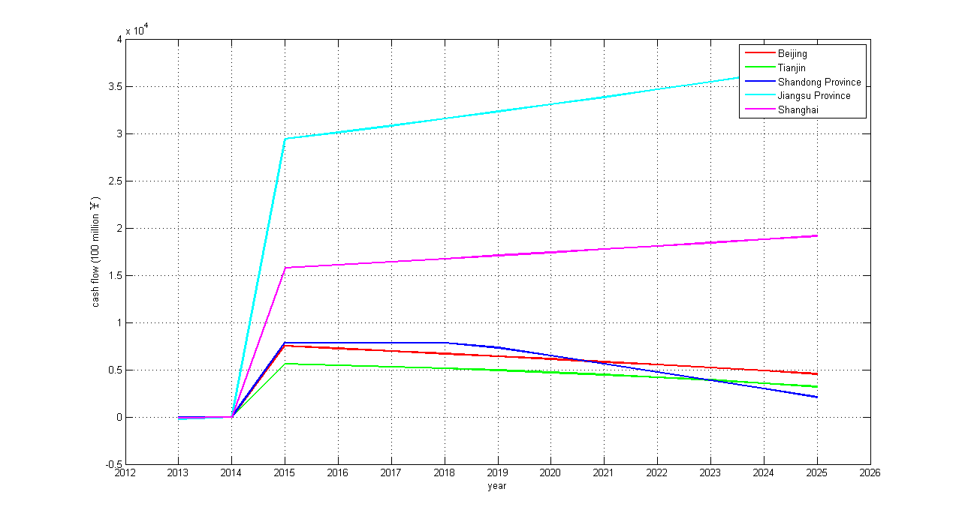

Figure 14: Cash flow of desalination plant in 6 provinces

**5.5 Strategy**

Without other strategies, we highly recommend coastal regions to adopt desalination if it is technologically and geographically feasible to resolve the water shortage problem in 2025. However, it should be noted that capacity of existing plant in Tianjin is mostly hampered by poor local infrastructure and the low demand for drinking water [15] . So when implementing desalination, the government should pay attention to better infrastructure construction and promote the desalinized drinking water.

**6 Strategy 4: Water Conservation**

Water conservation is as important as supply augmentation. In order to encourage citizens to conserve water and reduce waste, government has recently introduced such programs as increasing block tariffs, whose theoretical ground lies behind Ramsey Pricing. Through a case study of Shaanxi province, Liu and Gu [8] found that increasing block tariffs helps save about 15 water per person per year. So the projection seems quite promising to resolve water shortage problem in the future. Here, we focus on how to determine optimal increasing block tariffs, including water price and block cutoff.

Central to Ramsey Pricing is that the price markup should be inverse to the price elasticity of demand multiplied by a constant lower than 1[13] . Scholars have applied the theory into public service sectors, such as water sector, where government hopes to maximize social welfare rather than profit [2, 6] . So, we also use Ramsey Pricing model to propose optimal water price for different income consumers.

**6.1 Assumptions**

* **We partition each province into agriculture sector, industry sector and urban sector and consider optimal pricing in each sector independently.** Agriculture, industry and urban consumption are three major drives for water use, of which the respective percentage is 61%, 24%, 13% [10] .
* **Based on different income owned by consumers in each sector, we partition each sector into low income, medium income and high income.** Three blocks are used extensively both in theory and practice, because too many blocks are difficult to implement while too few blocks are ineffective in water conservation [9] .
* **Demand in each block is endogenous, which can be adjusted by water price.** Classic economic theory states that price is a strong tool to affect demand.
* **We consider government as the water supplier firm and the marginal cost and fixed cost remain the same for different groups in each sector.**
* **The government only requires that total revenue equal to total cost.** Unlike corporations, water supplier firm pays more attention to social welfare. Even it does generate profit, the profit is usually quite low [12] .
* **Pricing strategy is the same for three sectors.** For simplicity, the model presented below describes the strategy in one sector and can be applied in the other two.

**6.2 Notations**

* : Demand for different income groups, where i can be low, medium or high.
* : Price for different income groups, where i can be low, medium or high.
* : Demand elasticity for different income groups, where i can be low, medium or high.
* : Intercept in demand equation for different income groups, where i can be low, medium or high.
* : Total cost faced by the government.
* : Marginal cost faced by the government, which remains the same in each sector.
* : Fixed cost faced by the government, which remains the same in each sector.
* : Total revenue earned by the government.
* : Marginal social welfare for different income groups, where i can be low, medium or high.
* : Social welfare for each sector.

**6.3 Model**

Bailey [1] used linear regression and double logarithm linear regression to describe the demand based on water price and found that the latter fits the data better. Align with Bailey's finding, we also adopt double logarithm linear regression, which can be written as:

whereε , representing the demand elasticity for each group in one sector.

For the government, total cost can be written as:

and total revenue cost can be written as:

With one unit of water increased, consumers pay , and government pays MC. So the marginal social welfare can be written as:

We aim to determine an optimal demand to maximize total social welfare. The problem can be written as:

To get optimal demand, we use the method of Lagrange multipliers to get optimal price for each consumption group first. The optimization problem above can be rewritten as:

Taking first-order derivation of equation (6) to zero, we get:

As a result, for each consumption group, we have:

Expressing and in terms of , we get:

Plugging equation (7) and (8) into equation (4) and (5) and making total revenue equal to total cost, as we assumed, yields:

where,. Solving the equation \ref{e16}, we can achieve the optimal price for different amount of water consumption and further the optimal demand, which can be used as cutoff for the increasing block tariffs.

**6.4 Example Analyis and Strategy**

Agricultural sector accounts for the most in the total use, but only recently do some provinces, such as Hunan province, begin to charge irrigation cost due to difficulties in implementing. So it might be premature to adopt increasing block tariffs in agricultural sector.

Introduced into urban sector recently, increasing block tariffs has received extensive discussion in China. Considering optimal strategy in urban sector, we apply an example analysis to test its validity.\\

Demand elasticity is roughly between -1 and 0 according to the basic microeconomic theory. Jia and Kang [7] found that the figure is -0.346 in China. So we assign -0.4 to . In our model, low water consumption can be regarded as minimum requirement for water demand with a small elasticity of -0.7. The same logic applies to high water consumption group and we assign -0.1 to . For other parameters, we assign value subjectively (see Table 5).

Table 5: Notations

|  |  |  |
| --- | --- | --- |
|  |  |  |
|  |  |  |
|  |  |  |

The results, which are summarized in table 5 and figure, show that when the consumption below about , the optimal charge should be set at . When the consumption between and , the price should be . When the consumption exceeds . The results fit with common sense, but more thorough investigation should be taken to get more accurate value of parameters, which are essential for the final pricing policies.

Table 6: Example Analysis: Optimal Pricing Strategy

|  |  |  |  |
| --- | --- | --- | --- |
|  | First Block | Second Block | Third Block |
|  | 10.16 | 14.57 | 32.2 |
|  | 2.07 | 2.11 | 2.24 |

Depending on the data provided by Liu and Gu [8] , we apply the results above to Xi'an city and obtain water saving per person per year, even more effective than the existing plan, indicating the strength of our method. However, thorough investigation should be taken to get more accurate estimations of parameters, which are essential for the final pricing policies, but we believe it is a strong tool to help government make wise decisions.

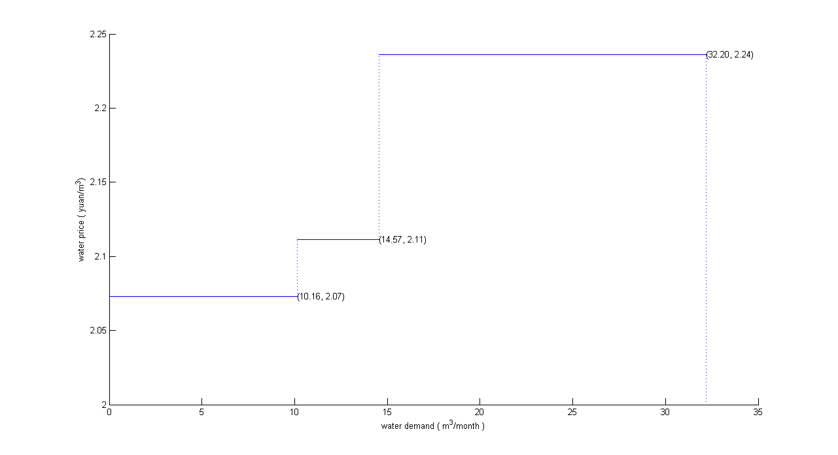

Figure 15: Example Analysis: Optimal Pricing Strategy

**7 A Comprehensive Strategy**

We now aim to synthesize four strategies discussed above into a comprehensive proposal for decision makers. We believe that each strategy has its pros and cons, which are summarized in Figure 16, and the government should adjust measures according to local conditions when addressing water shortage.

**Water transfer** is advantageous in emergency situations, and is especially useful in dealing with uneven spatial distribution of water resource. However, water transfer project incurs a great amount of money and takes a long time to construct. **Water storage** is easy to implement in the sense that reservoirs are located near large rivers and enjoy easy access to water. The location of a reservoir, however, is also its limitation since it might also bring such negative impacts as too much pressure imposed on ecological environment. The strategy applies best when downstream demand is relatively stable, i.e., no major unexpected emergency arises. **Desalinization** produces water of higher quality, making it a powerful tool in regions that are lacking clean, usable water. While the strategy has almost unlimited source of water and can produce by-product such as salt, its cost relies heavily on related technology. Desalinization can only be applied in coastal regions now and we also recommend that it be adopted in developed cities first because it requires related infrastructure and market of drinking water. **Increasing block tariffs pricing** can be widely used in cities, with ease of implementation and relatively low cost. But the market response, reflected in demand reduction, might have time lag.

Based on two criteria, which are inland area *versus* coastal area and uncertain water demand *versus* certain water demand, we can categorize four strategies into two dimension coordinate, as seen in Figure 17. We define level of demand certainty as variations of historical data, which can be accessed by the department concerned.

Combined with our prediction of water gap, we propose 4 specific plans now to deal with the problem in 2025.

1. Priority should be given to **Jiangsu province** since it will suffer most from water shortage. Jiangsu is a relatively developed province, so we recommend **water storage, 5 desalinization plants and increasing block tariffs**. Many reservoirs are located in Jiangsu, department concerned should pay attention to make stock policy based on our news-vendor model. 5 desalinization plants are suitable considering other strategies to cut water gap. In fact, IBT has been introduced into Nanjing city and Nantong city, and we highly recommend that it be promoted across the province by using our model provided. Investigation should be careful carried out to estimate parameters precisely.
2. Strategic position as it is in China, **Shanghai** also should be on top lists. Like Jiangsu province, Shanghai is a highly developed city along the coast and it is characteristic of scarcity of clean water, so we recommend **1 desalinization plant and increasing block tariffs** Considering high purchase power of consumers in Shanghai, we predict that the price set at large water consumption level should be higher than that in other cities, if our model is used correctly.
3. **Henan** is representative of inland area which mainly depends on agriculture, so we recommend **water storage** to solve the problem since the mainstream of Yellow river flows through He'nan province. Decisions should be carefully made on how much water needed to store for later gap. We believe our news-vendor model can help government make wise decision.
4. For **Beijing, Tianjin and Shandong province**, we recommend **1 desalination in each region, water transfer from southern area and increasing block tariffs.** Three neighbouring provinces can generate great synergy. Typical of scarce water resource, northern China is direct beneficiary of water transfer project.

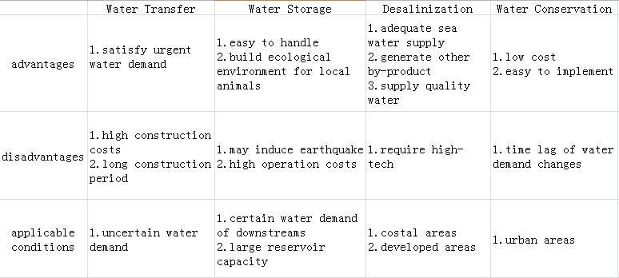

Figure 16: Pros and Cons of different models

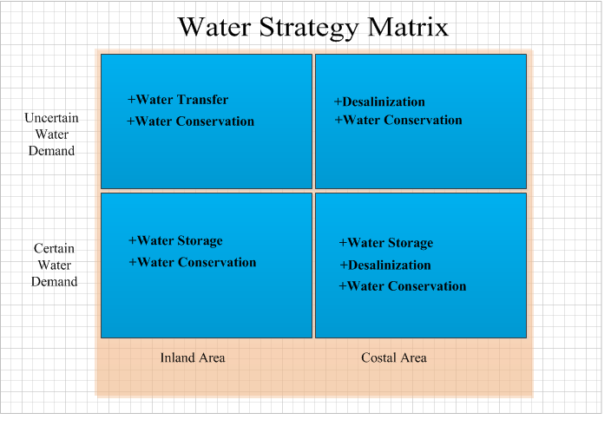

Figure 17: Categorization of four strategies

**8 Conclusion**

**Q1: What is the estimated water demand and available water supply in 2025?**

Based on grey model, we predict that **15** provinces will be in short of water in 2025, most of which are located in northern China. Jiangsu province will be most endangered by water shortage, with a gap of 58.32 billion yuan.

**Q2: How to solve the foreseen gaps?**

Considering spatial distribution, we apply a transportation model to address water transfer. Partitioning the vast country into seven river basins and summing up water gaps of provinces belonging to the region, we find that the Haihe Basin and the Yellow River Basin will be short of water in 2025. Assuming transport cost is proportional to distance, we get the optimal transfer strategy in which the Songliao Basin transfers water to the Haihe Basin and the Long River Basin to the Yellow River Basin, with a total cost of 14.88 yuan.

Considering temporal distribution, we apply a news-vendor model to address water storage. Regarding reservoirs as distributors who order water from its upstream to satisfy demands of its downstream, we aim to figure the optimal level of storage reservoirs need to prepare for future use. A case study of Three Gorges Reservoir reveals that should be stored to meet the demand of its downstream, including Jiangsu, Anhui and Shanghai.

Considering supply augmentation, we apply a NPV method to determine whether to establish desalinization plant. We first narrow down the potential locations to 5 provinces that will suffer water shortage in 2025 along the coast and obtain the number of plants needed under the assumption that water gaps must be satisfied. Upon reasonable assumptions about costs and benefits, we find that NPV of the project in each province is positive, indicating that desalinization is economically and socially promising to solve the water shortage.

Considering demand constraint, we apply Ramsey pricing model to address water conservation. We aim to propose an optimal increasing block tariffs based on different water consumption. Through a relatively subjective example analysis, we demonstrate the validity of the model, but more precise estimation of parameters are needed to get the final result.

**Q3: How to implement four strategies properly?**

Four strategies have their own pros and cons, so we should take measures according to local conditions. In order to provide a succinct and clear guide for government to make decisions, we categorized strategies according to two criteria, which are inland area versus coastal area and uncertain water demand versus certain water demand. Desalination and increasing block tariffs should be adopted in cities rather than rural areas.

For those which will face water shortage in 2025, we propose detailed plans. More specifically, we recommend Jiangsu adopt water storage, desalination and increasing block tariffs, Shanghai adopt desalination and increasing block tariffs, Henan adopt water storage and Beijing, Tianjin, Shandong combined adopt desalination and water transfer.

**9 Strength and Weakness**

One major problem facing us is the precision of data. Data from different resources follow different criteria, thus may present inconsistency overall. Also, although our data come from official sources like the National Bureau of Statistics of China, they are still subject to manipulation for many reasons. Different interpretations of data, on the other hand, lead to different result. Other data used for our parameter estimation, for example, per unit cost of water transportation, cost of building an desalinization plant and so forth is also hard to attain or estimate, these will greatly result in significant changes in final strategy should our estimation deviates from the intrinsic value.

However, to obtain the desired data is no easy job. These often require long-term surveys and study, as well as the assistance from expertise in related field. In several days, there is no way to accurately capture these data. Acknowledging this fact, we manage to build conceptual models with logical reasoning and mathematical calculation (The grey model is an exception. The reason for using a grey model is discussed in the section of prediction and an alternative conceptual model is also offered.), under the assumption that we have a precise data. This way, we are able to modify our final strategies as soon as we obtain more accurate data, say, from the government or other sources, without doing many burdensome repetitions.

**10 A Non-technical Position Paper to Governmental Leadership**

To Whom It May Concern,

We are writing this position paper to suggest a best strategy which combines desalinization, conservation, movement and storage to help you tackle with projected water shortage facing China in 2025.

We estimate that situation will be quite severe in 2025. There will be about 15 provinces whose water needs cannot be covered by local water supplies. Jiangsu province, in particular, will be faced with 58.32 billion of water shortage. Beijing, Shanghai and several other provinces also will be short of fresh water.

We suggest that in year 2025, the best water transfer strategy is to transport 12.32 billion of water from the Songliao Region to the Haihe Region, and 5.2 billion of water from the Long River to the Yellow River. On the other hand, our study on the Three Gorges Dam suggests that the Dam should store 84.1 billion of water from upstream to satisfy water needs in its downstream. For cities desalinization plants should be built in Shanghai, and several more in other provinces in need of water. The example of Shaanxi province tells us that an increasing block tariff pricing policy can well constrain water demands.

More specifically, in order to tackle with the severe water shortage in Jiangsu province, we suggest an increasing block tariff pricing policy combined with construction of 5 desalinization plants. Using more efficient storage strategy in water reservoirs can significantly generate stable water supplies to meet the demand in the province.

Our methodology combines four strategies together to deal with water shortage in a complicated environment in China. Jointly, these strategies cover demands of different degree of urgency, and different geographical distribution. We are confident that under various situations, our strategy will yield an optimal solution for you.

However, a major problem we encounter in our study is the precision and creditability of data. Since our models are conceptual ones using logical reasoning and mathematical computation, we are able to modify our final strategies as soon as we obtain more accurate data. Therefore, if you are interested in our study and provide us with field expertise and more credible results, we are more than happy to determine an even more detailed and effective strategy. We hope that with our joint effort, we can best alleviate water shortage and fight for a bright for the Country.

Best regards,

Team #17444

**References**

[1] Bailey WR, Modeling domestic water tariffs[R], Proceedings of the 2004 Water Institute of Southern Africa (WISA) Biennial Conference

[2] Boland JJ, Pricing urban water: Principles and compromises[J], Water Resource Update, 1992, 11(2):7-10

[3] David Seckler, Upali Amarasinghe, David Molden , et al [J], World Water Demand and Supply, 1990 to 2025: Scenarios and Issues, International Water Management Institute, 1998

[4] Deng J., Introduction to grey system theory[J], The Journal of Grey System, 1989, 1:1-24

[5] The Dow Chemical Company, China's Thirst for Water[R], 2011

[6] Henrique M and Catarina RP, Pricing for scarcity? An efficiency analysis of increasing block tariffs[J], Water Resource Research, 2011,47:1-11

[7] Jia SF, Kang DY, Influence of water price rising on water demand in north Chian[J], Advances in Water Science, 2000, 11(1):49-53

[8] Liu XJ, Gu Jinghua, Research on increasing block tariffs: A case study of Shanxi province[J]. Price: Theory and Practice, 2009, 2:22-23

[9] Ma XW, Study on pricing strategy of increasing block tariffs[J], Science Technology and Engineering, 2008, 8(24): 1671-1819

[10] The National Bureau of Statistics of China, Statistical Yearbook of China[DB/OL], 1999-2011

[11] Oelkers2011 EH, Hering JG, Zhu C, Water: Is there a global crisis?[J], Elements, 2011,7(3):157-162

[12] Pushpangdadan K, Murugan G, Pricing with changing welfare criteria: An application of Ramsey-Wilson model to urban water supply[J], Working paper, 1998

[13] Ramsey FP, A contribution to the theory of taxation[J], The Economic Journal, 1927, 37:47-61

[14] Water resource agency of Taiwan, the prospectus for desalinization plant in Taoyuan, Taiwan[R], 2008

[15] Watts, Jonathan, Can the sea solve China’s water crisis?[J], The Guardian, 2011

[16] Wikipedia, Desalination[EB/OL]

[17] Zhang YJ and Liu QS, Evaluation and preference for water demand prediction method[J], China Water and Wastewater Journal, 2001, 1000-4602(2001)07-0027-03

[18] Zhuo JW, Applications of MATLAB in mathematical modeling[M], Beihang University Press, 2011